**DAY - 1 ASSIGNMENT UNIX**

NAME : G.V.N.S KRISHNA VAMSI

TASK - 1

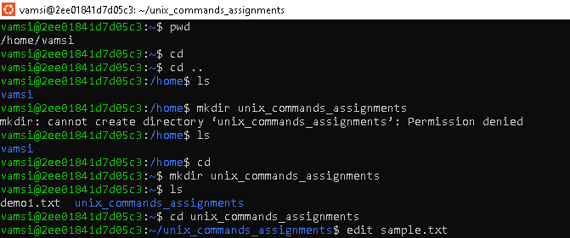

TASK - 2

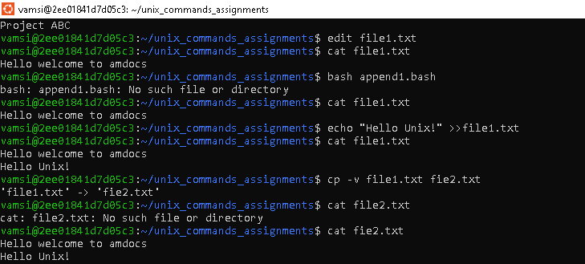

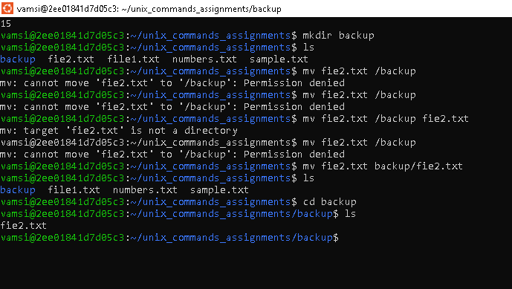

TASK -3

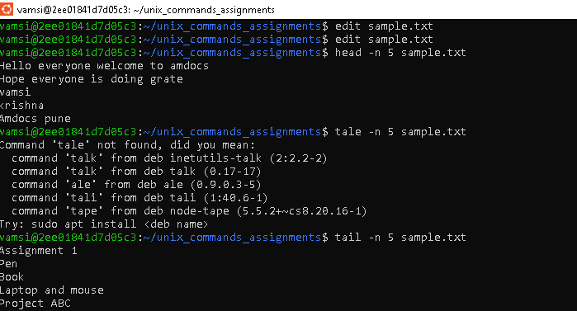

TASK -4

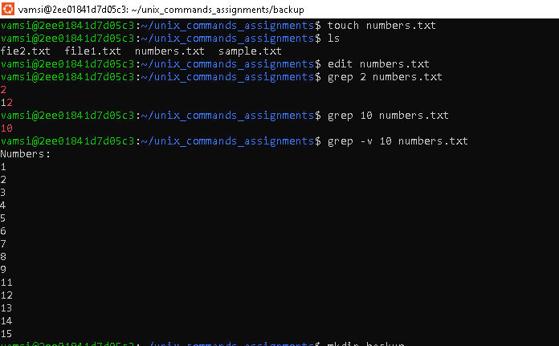

TASK -5

